
Rising Water:A Machine Learning Approach to Flood Prediction
Submitted By:
Akasapu Harika -akasapuharika0131@gmail.com
Atla Bhavitha Sri-bhavithaatla2@gmail.com
Kovela Jnaneswari-jnapikakovela@gmail.com
Vegi Harshith Naveen-harshithnaveenvegi@gmail.com
Kandula Poojitha -kandulapoojitha99@gmail.com


Abstract
Floods are among the most destructive natural disasters, causing significant damage to life, property, and the environment. This project presents a Machine Learning-based Flood Prediction System that analyzes rainfall and weather-related parameters to predict the likelihood of flooding. The system uses classification algorithms such as Decision Tree, Random Forest, K-Nearest Neighbors (KNN), and XGBoost to build predictive models.

After evaluating the performance of each model, the best-performing model is selected and deployed using a Flask web application.

The application provides a simple interface where users can enter weather-related information and instantly receive flood prediction results, helping improve disaster preparedness and awareness.

The collected data undergoes comprehensive preprocessing, including handling missing values, outlier detection, feature scaling, and dataset splitting, followed by exploratory data analysis using visualization techniques such as distribution plots, box plots, heat maps, and descriptive statistics. Multiple classification algorithms, including Decision Tree, Random Forest, K-Nearest Neighbors (KNN), and XGBoost, are trained and evaluated using performance metrics such as accuracy score, confusion matrix, and classification report.

Among these models, XGBoost demonstrates the highest prediction accuracy and is selected as the final model for deployment.


Problem Statement
Flood prediction is essential for reducing the impact of natural disasters and improving public safety. Traditional prediction methods often require extensive manual analysis and may not provide timely results. This project aims to develop an intelligent flood prediction system using Machine Learning that can accurately predict flood occurrence based on rainfall and meteorological data. The solution enables users to make informed decisions by providing quick and reliable flood risk predictions.

To address these challenges, there is a need for an intelligent and automated flood prediction system that can analyze historical weather and rainfall data to estimate the probability of flooding. Machine Learning techniques provide an effective solution by identifying hidden patterns and relationships within environmental data, enabling accurate predictions without extensive manual intervention.

The objective of this project is to design and develop a Machine Learning-based flood prediction system that utilizes meteorological parameters such as annual rainfall, seasonal rainfall, cloud visibility, and other weather-related features to predict flood occurrence.

The system performs data preprocessing, exploratory data analysis, feature engineering, and model training using multiple classification algorithms, including Decision Tree, Random Forest, K-Nearest Neighbors (KNN), and XGBoost. The best-performing model is selected based on evaluation metrics and deployed through a Flask web application.

The proposed solution provides users with a simple and interactive interface where they can enter weather-related inputs and instantly receive flood prediction results. By offering fast, reliable, and data-driven predictions, the system supports disaster preparedness, early warning, and informed decision-making, ultimately helping to minimize the impact of floods on communities and resources.


Features
- User-friendly Flask web interface.
- Predicts flood risk using Machine Learning.
- Uses weather and rainfall-related parameters.
- Performs data preprocessing and feature scaling.
- Compares multiple classification algorithms.
- Selects the best model based on prediction accuracy.
- Displays Flood Chance or No Flood Chance instantly.
- Model is saved and reused without retraining.
- Predicts the likelihood of floods using Machine Learning algorithms.
- Uses historical rainfall and meteorological data for accurate prediction.
- Compares model performance using evaluation metrics such as accuracy score, confusion matrix, precision, recall, and F1-score.
- Provides detailed exploratory data analysis through distribution plots, box plots, heat maps, correlation analysis, and descriptive statistics.
- Offers a user-friendly Flask web interface for easy interaction.
- Allows users to input rainfall and weather parameters through a web form.
- Generates instant predictions indicating Flood Chance or No Flood Chance.
- Saves the trained Machine Learning model using Joblib/Pickle for efficient reuse without retraining.
- Reduces prediction time by loading the pre-trained model during application runtime.
- Ensures consistent predictions by applying the same feature scaling used during model training.


Tech Stack
The technology stack used in this project combines Python, Machine Learning libraries, web development frameworks, and deployment tools to build an efficient and user-friendly flood prediction system. These technologies enable data processing, model training, visualization, application development, and cloud deployment.

Python
python is used as the primary programming language due to its simplicity and extensive support for data analysis, machine learning, and web development. It enables efficient implementation of the flood prediction system.

Flask
Flask is a lightweight and flexible Python web framework used to develop the web application for the flood prediction system. It acts as a bridge between the trained Machine Learning model and the user interface, allowing users to enter weather and rainfall data through a web page and receive instant flood prediction results.

HTML
HTML is used to develop responsive web pages that allow users to enter rainfall and weather-related parameters through input forms. These pages interact with the Flask backend to send user inputs and display the prediction results, providing a simple and user-friendly experience.

CSS
CSS (Cascading Style Sheets) is used to enhance the appearance and layout of the web application. It improves the user interface by adding colors, fonts, spacing, animations, and responsive designs, making the application visually appealing and easy to use.
CSS is applied to design the Home page, Prediction page, and Result pages, ensuring a clean, attractive, and user-friendly interface across different devices.


JavaScript
JavaScript is used to add interactivity and dynamic behavior to the web application. It enables client-side validation, improves user experience, and allows web pages to respond to user actions without requiring frequent page reloads.
JavaScript is used to validate user input, enhance form interactions, and provide a smoother and more responsive interface for flood prediction.

Pandas
Pandas is a powerful Python library used for data manipulation and analysis. It provides efficient data structures such as DataFrames that simplify the process of loading, organizing, filtering, and transforming datasets.
In this project, Pandas is used to read the flood prediction dataset, clean missing values, preprocess data, perform exploratory data analysis, and prepare the dataset for training Machine Learning models.

NumPy
NumPy is a fundamental Python library for numerical computing. It offers high-performance multidimensional arrays and mathematical functions that enable efficient numerical operations on large datasets.

Scikit-Learn
Scikit-Learn is used to split the dataset into training and testing sets, perform feature scaling, train classification models such as Decision Tree, Random Forest, and K-Nearest Neighbors (KNN), and evaluate model performance using metrics like accuracy score
Matplotlib & Seaborn
Matplotlib is used to create plots such as histograms, bar charts, and scatter plots, while Seaborn is used to generate advanced statistical visualizations such as heat maps, box plots, distribution plots, and correlation matrices.
These visualizations assist in exploratory data analysis, identifying outliers, and understanding the relationships between weather parameters and flood occurrence, ultimately improving the quality of the Machine Learning model.

Joblib
Joblib is a Python library used for efficient saving and loading of Machine Learning models and large data objects. It helps store trained models so they can be reused without performing the training process again.

,Joblib is used to save the trained flood prediction model and scaler after model training. The saved files are loaded by the Flask application to generate predictions quickly and efficiently.

Visual Studio Code
Visual Studio Code (VS Code) is a lightweight and powerful source code editor used for software and web application development. It provides features such as debugging, extensions, code completion, and integrated terminal support.
VS Code is used for writing Python programs, developing the Flask application, managing project files, and testing the flood prediction system.

Git & GitHub
Git is a distributed version control system used to track changes in source code and manage different versions of a project. GitHub is a cloud-based platform that allows developers to store, manage, and collaborate on projects using Git repositories.
Git and GitHub are used for maintaining project versions, organizing source code, backing up files, and enabling collaboration among team members during the development of the flood prediction system.


Installation steps
STEP :1
Install Python or Anaconda Navigator.
STEP :2
Open the project folder in Visual Studio Code.
STEP :3
Create and activate a virtual environment (optional).
STEP :4
Install the required libraries:
STEP :5
Place the dataset inside the project directory.
STEP :6
Run the training script: python train_model.py
STEP:7
Start the Flask application: python app.py
STEP:8
Open the browser and visit:
http://127.0.0.1:5000


Usage Instructions

1. Environment Setup
- Ensure that Python and Anaconda Navigator are installed on the system.
- Install all required dependencies and libraries such as NumPy, Pandas, Scikit-learn, Flask, XGBoost, Matplotlib, and Seaborn.
- Clone or download the project files and place them in the appropriate project directory.

2. Running the Application
- Open the project folder in Visual Studio Code or any suitable Python development environment.
- Open the terminal and run the Flask application using the command:
- python app.py
- Once the server starts successfully, open the application URL in a web browser.

3. Navigating the Web Application
- The Home Page provides information about the flood prediction system and available options.
- Click on the prediction option to access the input form.
- The user can enter required weather and rainfall parameters for analysis.

4. Providing Input Data
- Enter accurate values for environmental parameters such as:
  - Annual rainfall
  - Seasonal rainfall
  - Cloud visibility

  - Meteorological conditions
  - Other required weather attributes
- Ensure that all mandatory fields are filled before submitting the form.

5. Processing Prediction
- After submitting the input values, the Flask backend receives the data from the user interface.
- The input data is preprocessed using the same scaling technique applied during model training.
- The processed data is passed to the saved XGBoost Machine Learning model for prediction.

6. Viewing Prediction Results
- The system generates the prediction result within seconds.
- The output page displays one of the following results:
  - Flood Chance – Indicates a higher possibility of flood occurrence based on the given conditions.
  - No Flood Chance – Indicates a lower possibility of flood occurrence.

7. Model Integration
- The trained model file (floods.save) and scaler file are loaded automatically when the application starts.
- Users can perform multiple predictions without retraining the Machine Learning model.

8. Data Analysis and Visualization
- The project includes visualization modules that help analyze rainfall patterns, feature relationships, and data distribution.
- Graphs such as heat maps, box plots, and distribution plots help understand important factors affecting flood prediction.

9. Application Benefits
- Provides quick and automated flood risk assessment.
- Reduces manual analysis time.
- Helps users understand environmental conditions affecting flood probability.
- Supports disaster preparedness and early decision-making.
10. System Maintenance
- The dataset can be updated with new weather records to improve prediction accuracy.
- The Machine Learning model can be retrained periodically with updated data.
- Additional features and real-time weather information can be integrated for future improvements.

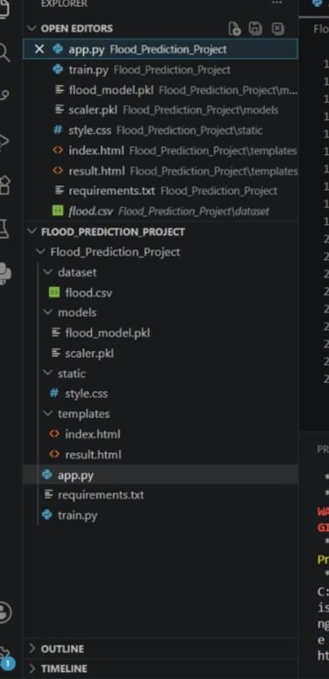



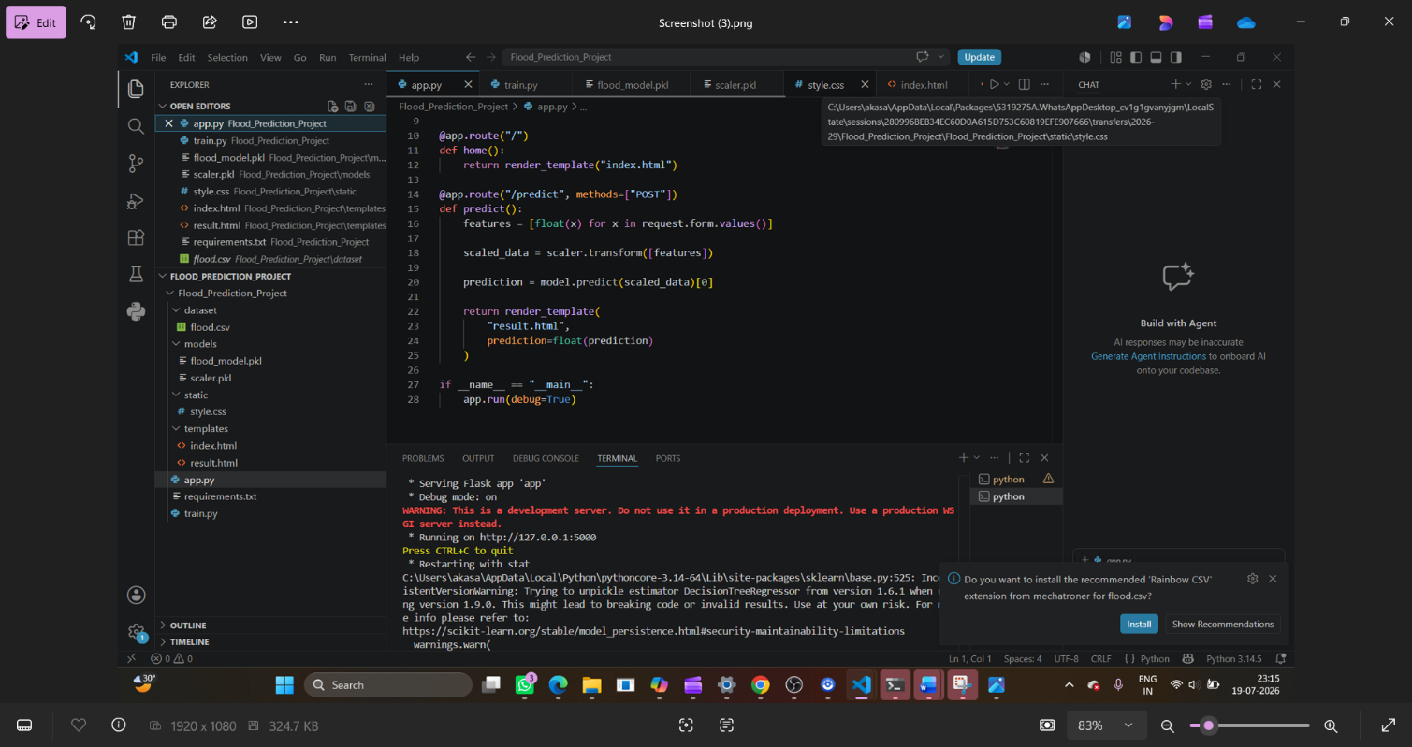



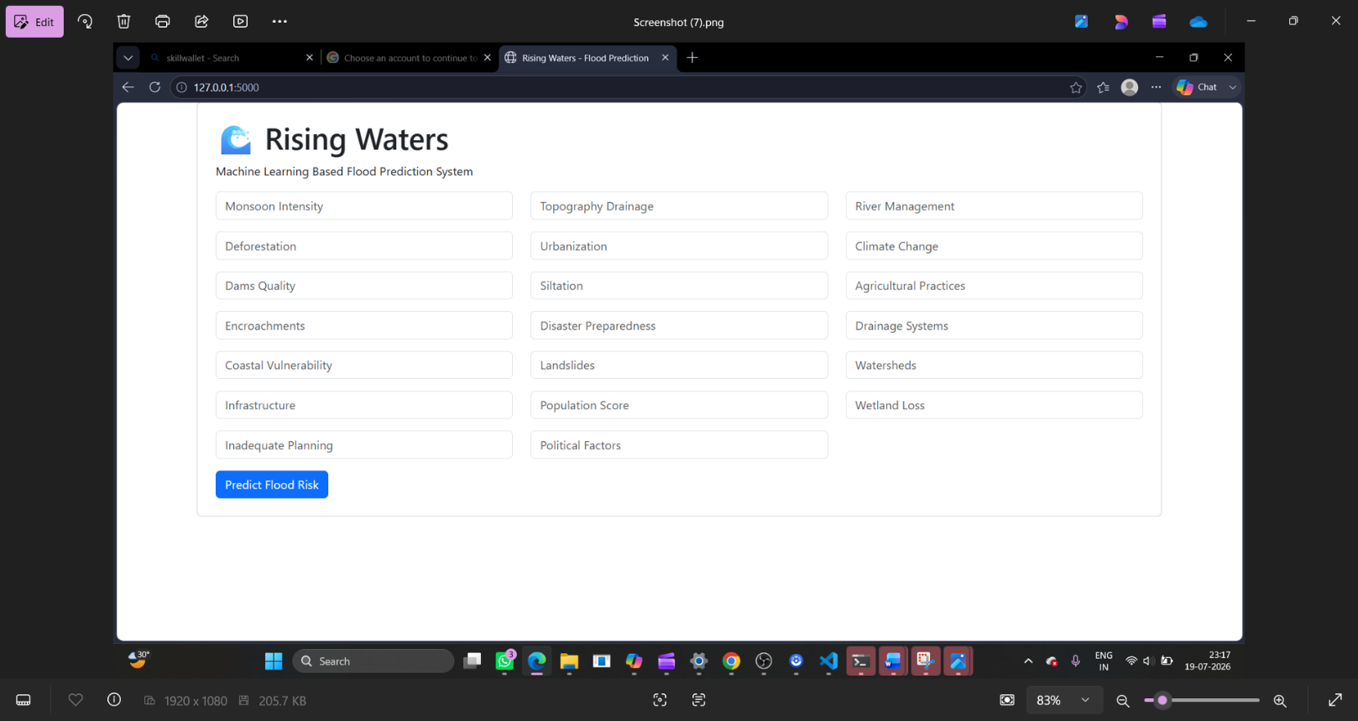



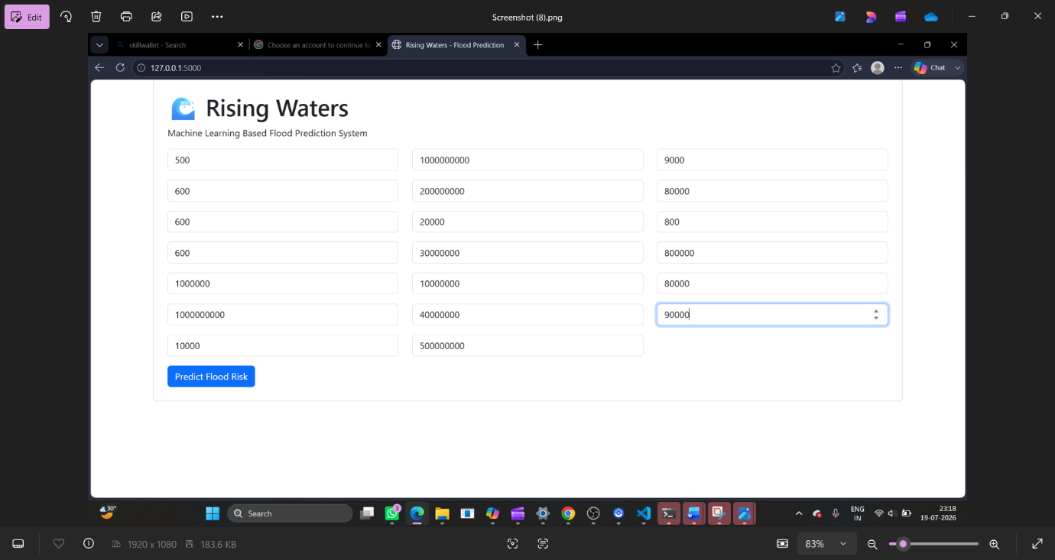



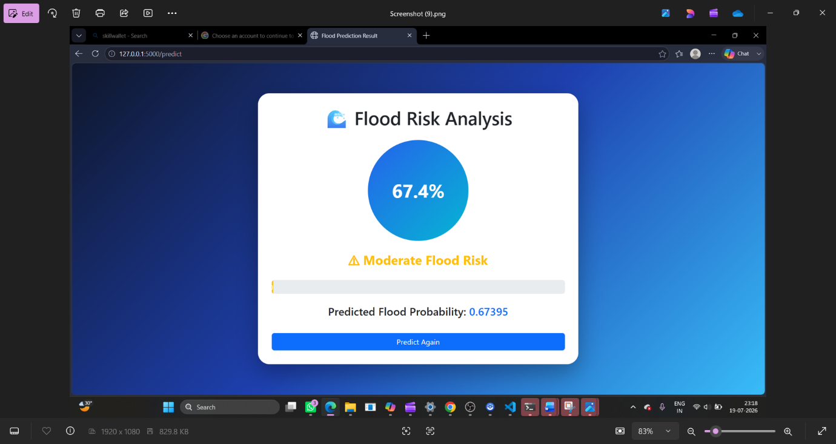


Future Scope
The Rising Waters: A Machine Learning Approach to Flood Prediction project can be further enhanced by integrating advanced technologies and real-time data sources to improve prediction accuracy and usability. Future improvements can transform the system into a more reliable and comprehensive flood monitoring and early warning solution.
- Real-Time Weather Data Integration
The system can be connected with real-time weather APIs to collect live rainfall, temperature, humidity, and atmospheric data, enabling dynamic and up-to-date flood predictions.
- Deep Learning Model Implementation
Advanced deep learning techniques such as Artificial Neural Networks (ANN), Recurrent Neural Networks (RNN), and Long Short-Term Memory (LSTM) networks can be implemented to analyze complex weather patterns and improve prediction accuracy.
- IoT-Based Flood Monitoring
IoT sensors can be integrated to collect real-time information from rivers, reservoirs, and flood-prone areas. Sensor data can help provide continuous monitoring and early flood warnings.
- Geographical Information System (GIS) Integration
The system can be enhanced with GIS and interactive maps to identify flood-prone regions and display risk levels based on geographical locations.
- Mobile Application Development
A dedicated Android and iOS mobile application can be developed to provide users with easy access to flood predictions, alerts, and safety information.
- Real-Time Alert and Notification System
The application can send emergency alerts through SMS, email, or mobile notifications when a high flood risk is detected.
- Cloud-Based Deployment
The system can be deployed on cloud platforms such as IBM Cloud to improve scalability, availability, and accessibility for users across different locations.
- Improved Dataset and Feature Expansion
The model can be trained using larger and more diverse datasets containing additional environmental factors such as river levels, soil moisture, wind speed, and historical flood records.
- Automated Model Updating
Machine Learning models can be continuously improved by automatically learning from newly collected weather and flood data.
- Multi-Region Flood Prediction
The system can be expanded to support flood predictions for multiple geographic regions and provide location-specific risk analysis.
- Integration with Disaster Management Systems
The prediction system can be connected with government and emergency response platforms to support faster rescue operations and effective disaster planning.
Overall, the future enhancements aim to develop a smart, real-time, and scalable flood prediction platform that can contribute to better disaster preparedness and reduction of flood-related damages.


Future Enhancements

The Rising Waters: A Machine Learning Approach to Flood Prediction system can be improved further by incorporating advanced technologies and additional features to make flood forecasting more accurate, reliable, and accessible.

- Integration of Real-Time Weather APIs:
Connect the system with live weather data sources to automatically collect rainfall, temperature, humidity, and other meteorological parameters for real-time flood prediction.

- Advanced Machine Learning and Deep Learning Models:
Implement advanced algorithms such as Artificial Neural Networks (ANN), LSTM, and other deep learning models to identify complex patterns and improve prediction accuracy.

- Mobile Application Development:
Develop a mobile application that allows users to access flood predictions, alerts, and safety information anytime and anywhere.

- Early Warning Alert System:
Add SMS, email, and push notification features to provide users with timely warnings during high flood-risk conditions.

- GIS and Map-Based Visualization:
Integrate geographical mapping systems to display flood-prone areas, risk zones, and affected locations visually.

- IoT Sensor Integration:
Connect IoT-based sensors to monitor water levels, rainfall intensity, and environmental conditions continuously for real-time monitoring.

- Cloud-Based Deployment:
Deploy the application on cloud platforms such as IBM Cloud to improve scalability, availability, and accessibility for a larger number of users.
- Larger and Updated Datasets:
Train the model using more extensive historical and real-time datasets to improve accuracy and adaptability across different regions.

- Automated Model Retraining:
Implement automatic model updates using newly collected data to maintain prediction performance over time.

- Multi-Language Support:
Add multiple language options to make the application accessible to users from different regions and communities.

These enhancements can transform the current flood prediction system into a complete disaster management solution capable of providing accurate forecasts, early warnings, and improved safety measures.


Project Workflow

The workflow of the Rising Waters: A Machine Learning Approach to Flood Prediction project is represented as a sequence of steps from data collection to deployment.

Environment Setup
↓
Dataset Collection (Rainfall and Weather Data)
↓
Data Exploration & Visualization (EDA)
↓
Data Preprocessing (Cleaning, Encoding, Scaling)
↓
Train-Test Data Splitting
↓
Model Training (Decision Tree, Random Forest, KNN, XGBoost)
↓
Model Evaluation (Accuracy, Confusion Matrix, Classification Report)
↓
Best Model Selection (XGBoost)
↓
Model Saving (floods.save)
↓
Flask Web Application Development
↓
User Input (Weather & Rainfall Parameters)
↓
Flood Prediction Using Trained Model
↓
Result Display (Flood Chance / No Flood Chance)
↓
Deployment on IBM Cloud (Optional)

Project Structure
Flood_Prediction_Project/
│
├── Dataset/
│ └── flood.csv # Flood prediction dataset
│
├── Model/
│ ├── flood_model.pkl # Trained XGBoost model
│ └── scaler.pkl # Saved feature scaler
│
│
├── Static/
│ │ └── style.css # Web page styling
│
├── Templates/
│ ├── index.html # Home page
│ ├── result.html # Flood result page
├── app.py # Flask application file
|___requirements.txt
|___train.py


Advantages

- Early Flood Risk Prediction:
The system helps predict the possibility of floods at an early stage using weather and rainfall data, supporting better disaster preparedness.
- Machine Learning-Based Accuracy:
Multiple Machine Learning algorithms are analyzed, and the best-performing model (XGBoost) is selected to provide reliable predictions.
- Automated Prediction System:
The system reduces manual analysis by automatically processing environmental data and generating flood risk results.
- Fast and Efficient Processing:
The trained model provides quick predictions without requiring repeated model training.
- User-Friendly Interface:
The Flask-based web application allows users to easily enter weather parameters and view prediction results.
- Data-Driven Decision Making:
The system identifies patterns and relationships in historical weather data to support informed decisions.
- Scalable and Deployable:
The application can be deployed on cloud platforms such as IBM Cloud for wider accessibility.
- Supports Disaster Management:
The system can assist authorities and communities in improving flood awareness and emergency planning.
- Cost Effective Solution:
It provides an affordable approach for flood prediction by utilizing Machine Learning techniques and available environmental data.

.
Conclusion

The Rising Waters: A Machine Learning Approach to Flood Prediction project successfully demonstrates the application of Machine Learning techniques in predicting flood risks using weather and rainfall data. The project involves complete data processing, exploratory data analysis, model training, evaluation, and deployment through a Flask web application.
Various classification algorithms, including Decision Tree, Random Forest, K-Nearest Neighbors, and XGBoost, are trained and compared. Based on performance evaluation, XGBoost is selected as the best model due to its higher accuracy and reliability. The developed system provides users with a simple interface to enter weather parameters and receive instant flood prediction results.
This project highlights the potential of Machine Learning in disaster management by providing a data-driven approach for early flood risk assessment. With future enhancements such as real-time weather integration, IoT monitoring, and cloud-based deployment, the system can be further developed into an advanced flood early warning solution that helps reduce the impact of natural disasters.

